

Implementation of Proposed System

Program Name: Software Engineering
Module Number: SWE5201
Module Name: Advanced Programming
Year/ Semester: 2024-25/ Semester 2
Module Tutor/s: Kishore Pashindla, Faisal Maramazi, Neelum Raffique
Student ID: HE27721
Date of Submission: 24 January 2026
Word Count: 1802
Table of Contents
Table of Figures 2
Introduction 2
System Overview 3
Variations to Original Design 3
Advanced Programming Techniques Used 4
Object-Oriented Programming Techniques 4
Modular Programming Techniques 5
Exception Handling 5
Design Pattern and Refactoring 6
Testing Methodologies 8
Unit Testing 9
Integration Testing 9
System Testing 10
User Acceptance Testing 10
Testing Limitations 10
Final Program Evaluation 11
Program Reliability 12
Error Handling, Logging, and Validation Mechanisms 12
Initial Requirements and Constraints 13
Limitations 14
Potential Improvements 14
Lessons Learned 14
Conclusion 15
Self-Reflection 15
References 16
Appendix 17
Database 17
User Registration 22
User Login 25
GUI 25

Table of Figures

Figure 1Try-catch used in Registration form code 5
Figure 2 Output of example 6
Figure 3 Bit of code before refactoring 7
Figure 4 Output before refactoring 7
Figure 5 Same code after refactoring 8
Figure 6 Output after refactoring 8
Figure 7 Example of error handling 13

Introduction
This document contains the implementation of a ticket booking system designed in Assignment 1 that lets users browse events, book tickets, and manage basic booking actions.
This report presents decisions regarding implementation, applied programming techniques, testing approaches, and self-reflection.
The system was created by following the Software Development Life Cycle (SDLC).

System Overview
The purpose of the system is to reduce manual ticket booking and improve efficiency for organisers, administrators, and customers.
The core functions of the system include user registration/login, viewing events, booking tickets, payments and admin/ organizer oversight.
The system is written in C#, it is a Window Forms application in Visual Studio and can store data.
Users can search for events through a graphical interface.
The system uses object-oriented principles, like encapsulation and modular design.
The implementation of the system is based on the design produced in Assigment1, with some adjustments.

Variations to Original Design
Some features proposed in Assignment 1 were dropped during implementation. While the original design reached for a fully functional payment processing, due to time and complexity, a basic form was implemented.
Certain administrative features were kept to a basic functionality level to keep the system stable and working. This choice was made to ensure the data flow remains functional.
“It is unavoidable that software evolves to meet user requirements, but any modifications must be performed with an eye toward maintaining both functional and non-functional qualities.” (Arasteh, 2023)

Advanced Programming Techniques Used

Object-Oriented Programming Techniques
“C# is a powerful and versatile Object-Oriented Programming (OOP) language.” (Hales, 2022). Because of that, it is the choice in this project to create classes that represent real entities like User, Event, Ticket, and Payment. Each class has specific attributes and methods.
The system uses Object-Oriented programming principles when it separates into many classes and forms. User-related logic is handled separately from user interface by a repository class. This class encapsulates database access and execution.
This approach ensures that interface and layers are separated, improving maintainability and readability of code.
Input validation is implemented at the user interface level to ensure that invalid or incomplete data is not passed to the database. For example, user registration enforces minimum password length and has required field checks. This protects the database from irrelevant operations.

Modular Programming Techniques
The modular structure involves the system’s division into classes with individual responsibilities. This reduces dependency between components: if one module goes through changes, the others are minimally impacted.
This type of programming makes debugging and future extensions easier to apply and it also shows good software engineering practice.

Exception Handling
Exception handling is used to prevent system crashes. Here, it is used around database interactions and it helps provide feedback to the user in case of connection or execution failures. This is important for user input errors.
By using try-catch methods around user input and data operations, the system can handle input and manage errors easily, helping debugging and strengthening system reliability.
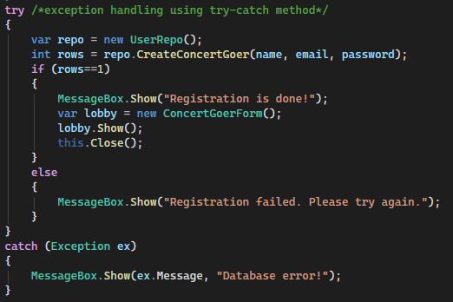
Figure 1Try-catch used in Registration form code
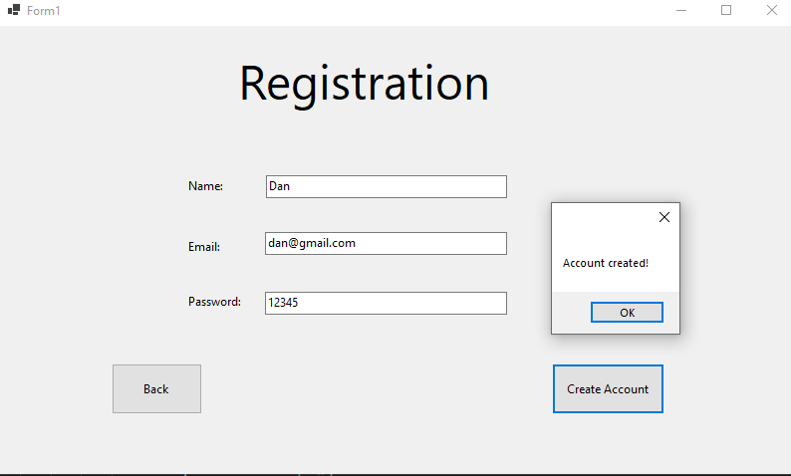
Figure 2 Output of example
This action improves user experience and supports debugging during development. It also increased system reliability.

Design Pattern and Refactoring
The chosen design pattern ended up being Repository.
This choice was made to separate data handling from user interface. Data logic was separated into classes, preventing direct database interaction from the user interface. This improves readability, maintainability and it also shows clean code principles.
“[..] most researchers consider maintainability as purely a non-functional requirement with no relation to security. This has been identified to be a major source of security concerns.” (Kadebu, 2023)
Another advantage is future changes like database updates or replacements are made easier.
To improve code clarity even more, refactoring was used.
“Refactoring operators efficiently eliminate antipatterns, but they must first be identified.” (Kalhor, 2024)
Duplicate logic was removed and conditional logic was simplified – by using ternary operator.
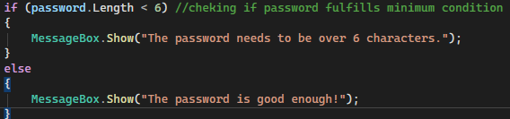
Figure 3 Bit of code before refactoring
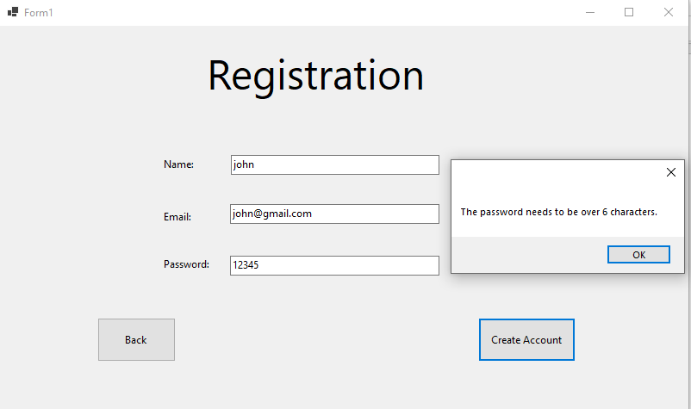
Figure 4 Output before refactoring
Figure 5 Same code after refactoring
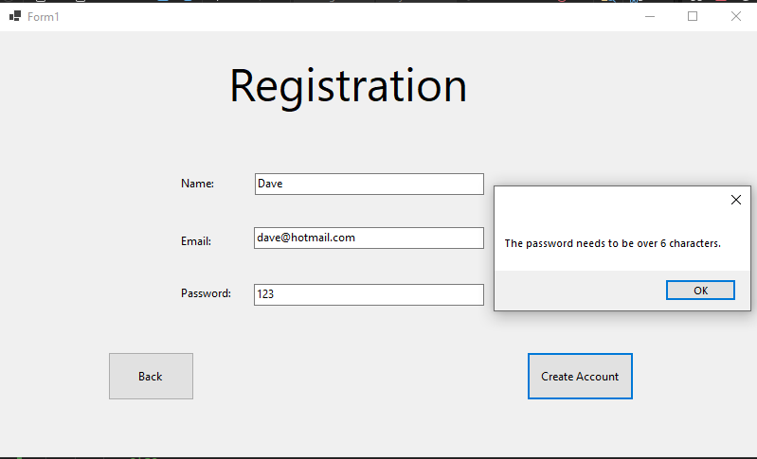
Figure 6 Output after refactoring
Variable and method names were changed for readability.
All these changes reduced code complexity.

Testing Methodologies
“Software testing is a crucial undertaking that serves as a cornerstone for ensuring the quality and reliability of software products.” (Wang, 2024)
Testing was handled through manual execution of system workflows. Manual testing was chosen due to the limited scale of the system and the absence of automated testing frameworks within the project scope. In spite of this, structured test scenarios were followed to ensure consistent coverage of basic functionality. These scenarios involved successful and unsuccessful user registration attempts, valid and invalid login credentials, and navigation between system forms.
This ensured that core requirements were being met, while allowing rapid feedback during development.
Automated testing in the future could improve long-term reliability, but the current testing strategy was sufficient to validate system behaviour within the defined constraints.

Unit Testing
Unit testing focuses on testing individual components and it also identifies logic errors early in implementation.
In this system, unit testing focused on validating individual methods, such as input validation and authentication logic through providing both valid and invalid inputs.
“A developer may be rigorously testing a class and suddenly notice that a coding decision they made a few hours ago was not ideal.” (Aniche, 2022)

Integration Testing
Integration testing is used to check interactions between system components.
The focus of this process is to see how data flows between classes. It also makes sure that all the components interact well with each other.
In this system, integration testing was performed by verifying the interaction between the application and the MySQL database. This included testing successful database connections, inserting new user records during registration, and retrieving existing records during login. (See Appendix)

System Testing
System testing involves executing complete user workflows, like navigation between forms, user registration, and login functionality.
The result showed that the system meets functional requirements with a focus on stability and usability.

User Acceptance Testing
User acceptance testing was used to check system usability, enduring that system messages were clear, and that navigations was intuitive.
Mock user input was tested from an end-user point-of-view.
The feedback involved system clarity and easy system navigation.
This shed light on areas of system improvement.

Testing Limitations
In future development, automated testing could be expanded.
“Testing software and systems is necessary to avoid failures visible to customers and avoid bad publicity for the organizations involved.” (Homes, 2024)
Due to the system’s small scale the performance testing was kept to a minimum.

Final Program Evaluation
The implemented system meets the main objectives presented in the original design documentation to a basic level given the project scope.
The completed system shows a balance between functional requirements and practical constraints. While not all planned features were fully implemented, the system demonstrates a working end-to-end flow of core user actions, supported by database persistence and structured validation. This confirms the technical feasibility of the original design while also bringing to light areas where scope management had a very important role in final delivery.
From a technical perspective, the project showed the importance of planning data structures and application flow early in development.
Initial challenges included managing navigation and database connectivity, but they were solved through continuous development and testing.
The implementation of a database-backed registration and login system showed understanding of real-world application design, especially related to data validation, error handling, and user authentication. The project also showed the importance of modular architecture, as separating layers allowed functions to be added without destabilizing existing code.
Evidence of database connectivity and implementation is provided in Appendix.
User registration and authentication was implemented and verified using a MySQL database, with supporting evidence in Appendix.
The system shows correct use of object-oriented design principles, even if some features were simplified or only partly implemented.
In general, the application is functional, it meets some of the core objectives from the defined scope, and provides a solid foundation for future upgrades, like expanded user management and automated testing.

Program Reliability
“From small businesses to global enterprises, efficient and reliable software development processes are key to implementing technological solutions.” (Li, 2024)
The system’s reliability comes through input validation and exception handling.
The application was tested under different scenarios to ensure system stability, but due to its limited scale, it is not suitable for high-load environments.

Error Handling, Logging, and Validation Mechanisms
Error handling was present through try-catch blocks, which prevented application crashes.
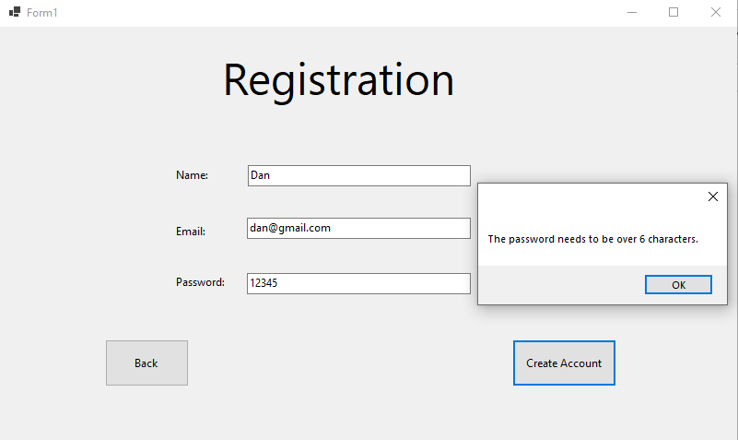
Figure 7 Example of error handling
While logging was limited, the user input was validated to reduce invalid data entry and error messages were used to support debugging.
All these actions improved overall system stability and user experience.

Initial Requirements and Constraints
The system was developed based on the requirements defined in Assignment 1.
Key constraints include time, complexity, and learning curve, so adjustments were made to prioritise functionality. This also influenced design and implementation decisions.

Limitations
The current system supports only limited users, with simple payment processing and basic notifications.
Data integration could be expanded.
These limitations show project scope and development period.
Additionally, the system was developed as a standalone desktop application, which limits accessibility compared to a web-based solution. Multi-users and deployment considerations were not addressed due to scope constraints. These limitations are acceptable within the academic context but highlight future considerations for real-world implementation.

Potential Improvements
Implementing structured logging and role-based access control would further enhance system maintainability, traceability, and overall security.
Enhancing security methods and expanding automated testing would improve even further system reliability..

Lessons Learned
After this project, more knowledge about Visual Studio and about using object-oriented principles in a project was gained. This led to more confidence in handling implementation, testing and debugging.

Conclusion
This document presents the development of a ticket booking system, covering programming techniques, design patterns, and testing.
Due to time contraints, the system is basic but functional and meets the core requirements of the project.
The system shows future potential by adding more functions and improving scalability.
Overall, the projet demonstrates practical application of core software engineering principles and has huge potential.
“We want an artifact that satisfies our requirements, validates feasibility, and supports evaluation.” (Blaess, 2025)

Self-Reflection
During this project, I reflected on my technical development and skills. It was also difficult to get started on writing, but once I did, everything went as smoothly as expected.
Windows forms took me a while to learn. There was a lot of trial and error. I had to restart from scratch at least half a dozen times. But now I know I can handle creating forms, making changes, buttons, and if I encounter an issue, dealing with it. It improved my patience, sparked my creativity and curiosity, but also tested my determination to finish the project.
“Many professional .NET developers use Visual Studio in their day-to-day development work.” (Price, 2024)

References
Aniche, M. (2022). Effective Software Testing: A Developer's Guide. New York: Manning Publications Co.
Arasteh, B. S.-M. (2023). Program Source-Code Re-Modularization Using a Discretized and Modified Sand Cat Swarm Optimization Algorithm. Symmetry, 15(2), 401-402. doi:10.3390/sym15020401
Blaess, H. (2025). Semi-Automitic Generation of Production Exception Handling for Agile Process Guidance. Wien: Doctoral Dissertation.
Hales, J. K. (2022). The C# Workshop. Birmingham: Packt Publishing Ltd.
Homes, B. (2024). Fundamentals of Software Testing: 2nd Edition Revised and Updated. New Jersey: John Wiley & Sons, Inc.
Kadebu, P. S. (2023). A Classification Approach for Software Requirements towards Maintainable Security. Scientific African, 19(3). doi:10.1016/j.sciaf.2022.e01496
Kalhor, S. K. (2024). A Systematic Review of Refactoring opportunities by Software Antipattern Detection. Automated Software Engineering, 31(2), 42-43.
Li, K. Z. (2024). Utilizing Deep Learning to Optimize Software Development Processes. Journal of Computer Technology and Applied Mathematics, 1(1). doi:10.5281/zenodo.11004006
Price, M. J. (2024). C# 13 and .NET: Modern Cross-Platform Development Fundamentals. Birmingham: Packt Publishing Ltd.
Wang, J. H. (2024). Software Testing With a Large Language Models: Survey, Landscape, and Vision. IEEE Transactions on Software Engineering, 50(4), 911-936. doi:10.1109/TSE.2024.3368208

Appendix

Database
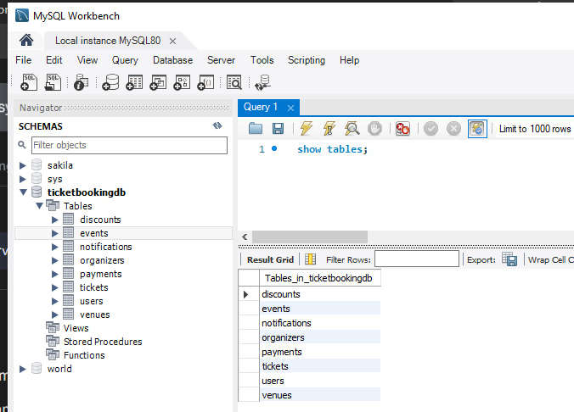
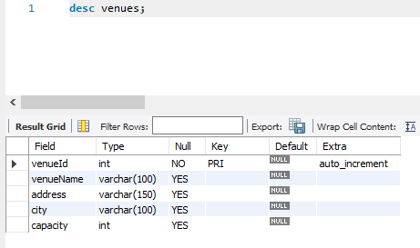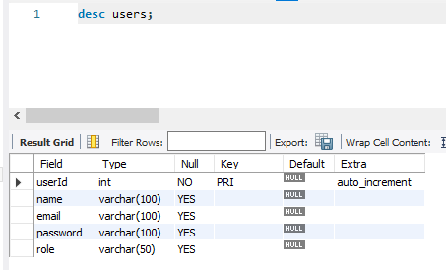
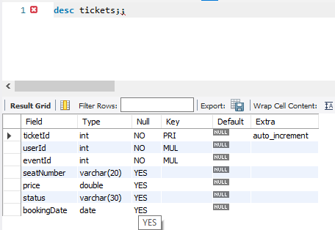
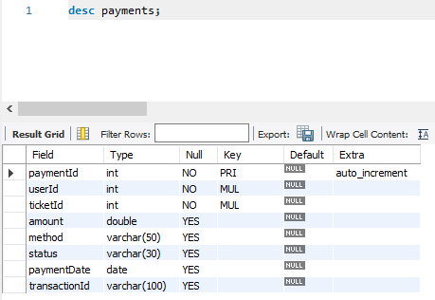
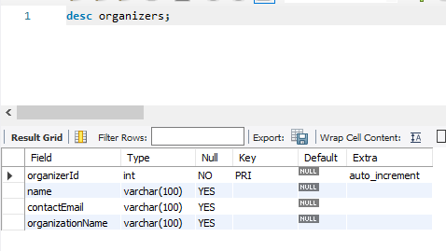
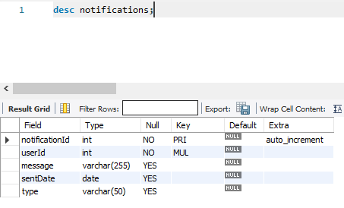
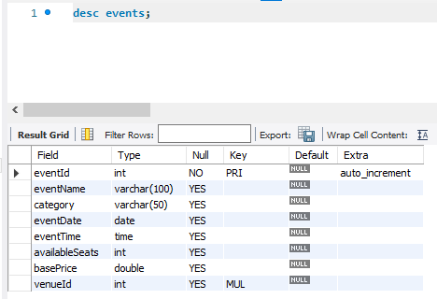
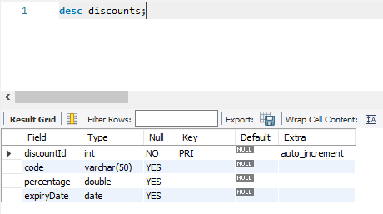

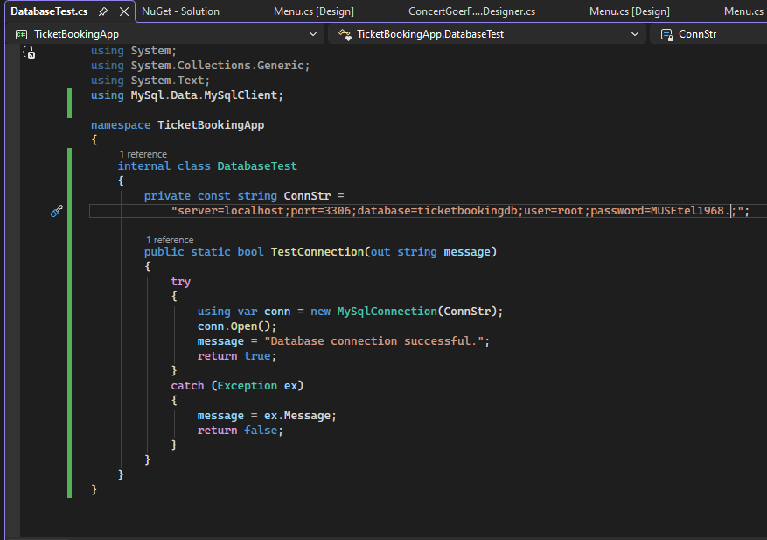
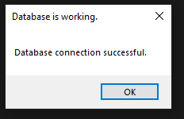

User Registration

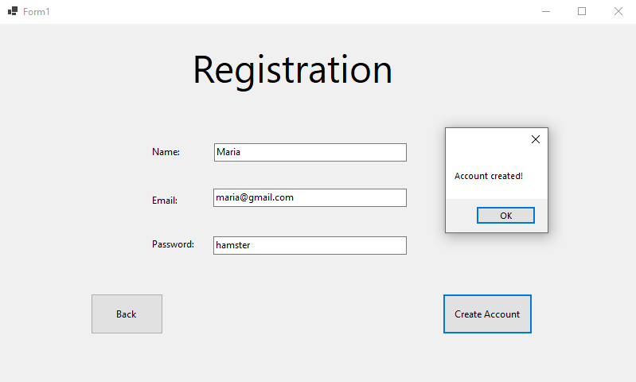

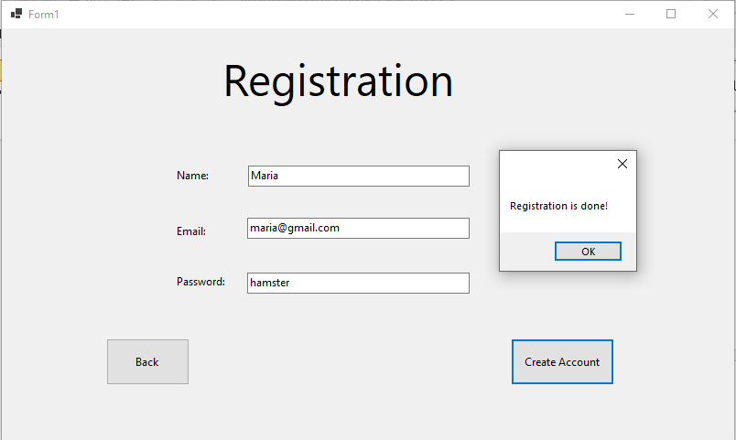

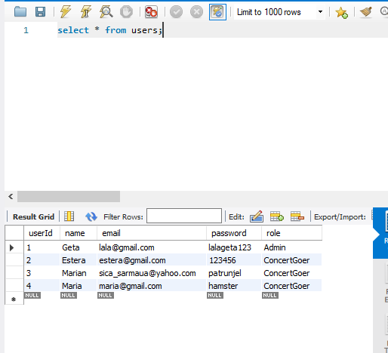

User Login
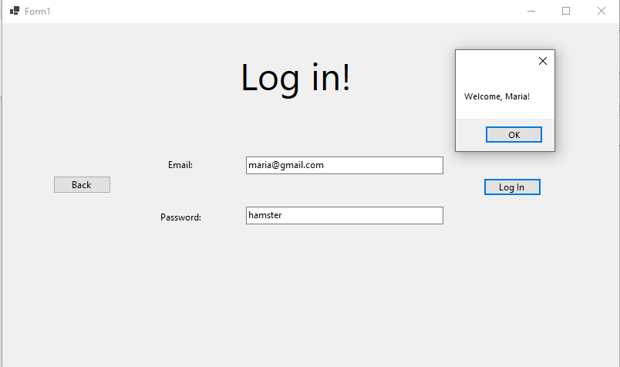

GUI


